Se11. Utilities->Other Dictionary Objects

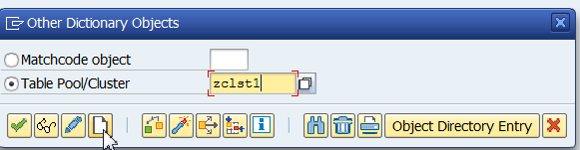

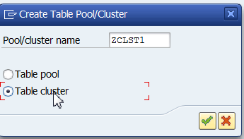

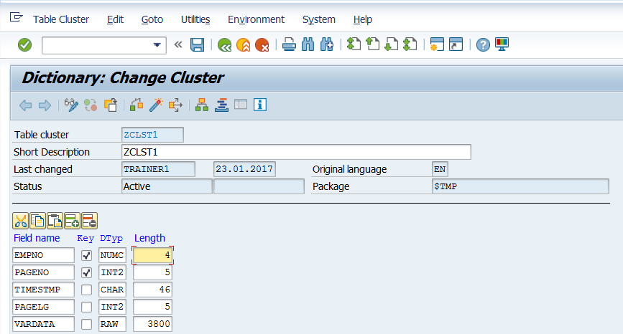

Change Key from Varkey Length 110 to Numc 4. This is because the ZVKEMP table that we are creating later has that key.

Save and Activate.

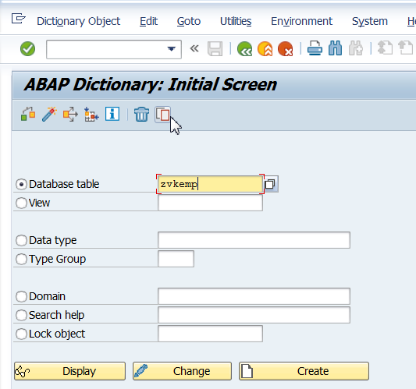

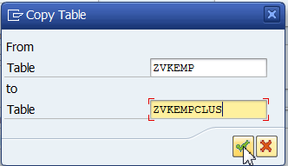

Open EMPCLUS table in change mode.

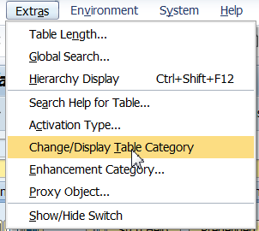

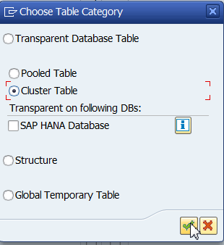

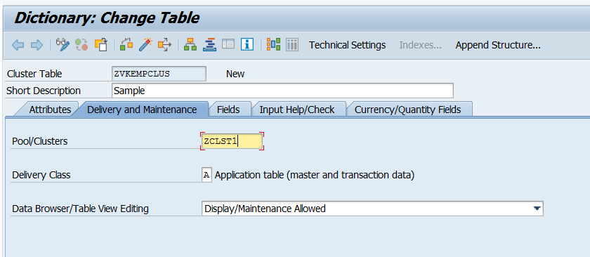

A pool table can be created in the same way. No common key is required for that.

This way we can have many tables belonging to the same cluster/pool.

Activate the table.